**DBMS Assignment-3B**

Q1: Explain DML commands.

Data Manipulation Language (DML) statements or commands are used for managing data within tables. Some commands of DML are:

Insert :

The insert statement is used to add new row to a table.

Syntax: INSERT INTO <table name> VALUES (<value 1>, ... <value n>);

Example:

INSERT INTO STUDENT VALUES (1001,‘Ram’);

The inserted values must match the table structure exactly in the number of attributes and the data type of each attribute. Character type values are always enclosed in single quotes; number values are never in quotes; date values are often (but not always) in the format ‘yyyy-mm-dd’ (for example, ‘2006-11- 30’).

#### UPDATE :

The update statement is used to change values that are already in a table.

 UPDATE <table name> SET <attribute> = <expression> WHERE <condition>;

Example:

UPDATE STUDENT SET Name = ‘Amar’ WHERE StudID=1001;

The update expression can be a constant, any computed value, or even the result of a SELECT statement that returns a single row and a single column.

#### DELETE :

The delete statement deletes row(s) from a table.

DELETE FROM <table name> WHERE <condition>;

Example:

DELETE FROM STUDENT WHERE StudID=1001;

If the WHERE clause is omitted, then every row of the table is deleted that matches with the specified condition.

#### SELECT :

The SELECT statement is used to form queries for extracting information out of the database.

SELECT <attribute>, ….., <attribute n> FROM <table name>;

Example:

SELECT StudID, Name FROM STUDENT;

Q2. Insert 5 tuples in each of the created tables.

Ans:

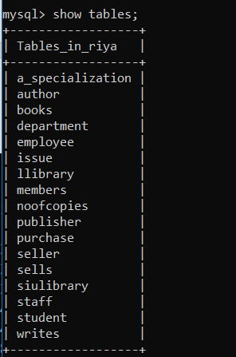

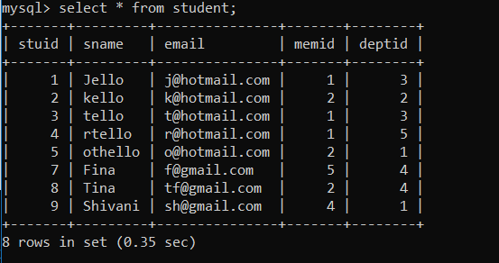

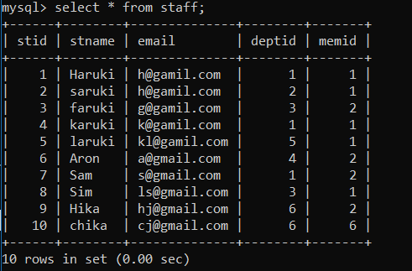

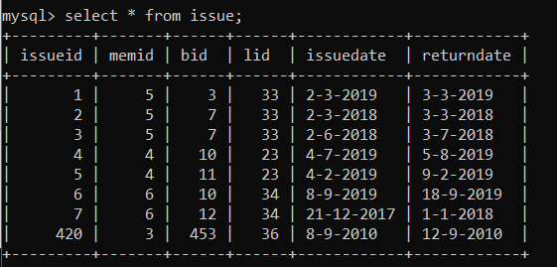

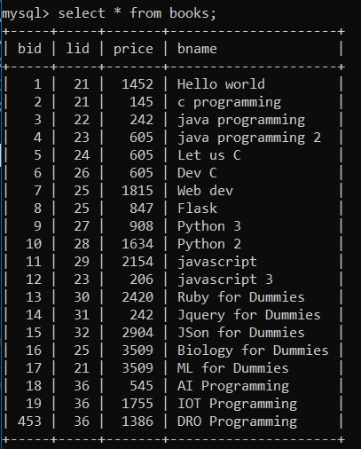

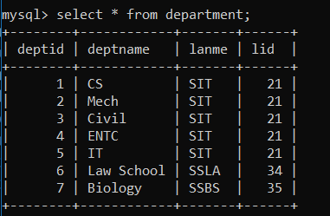

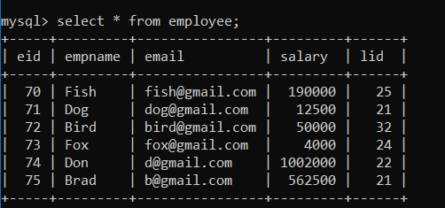

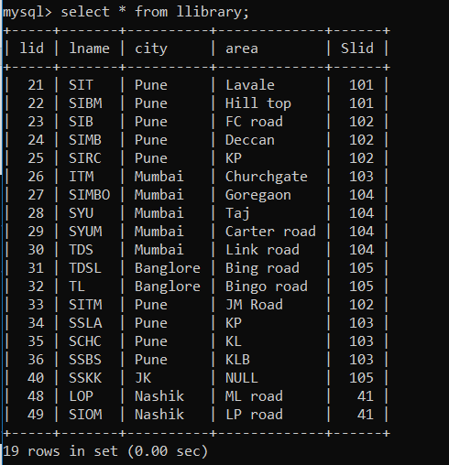

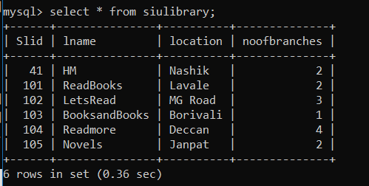

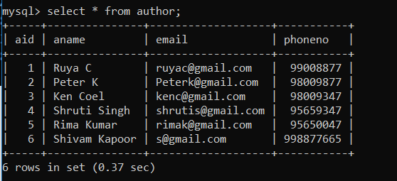

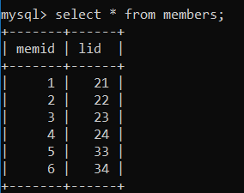

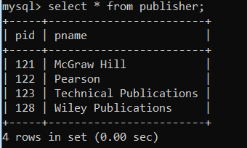

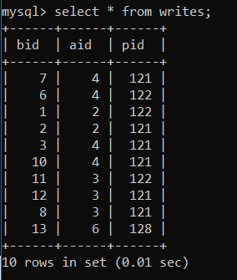

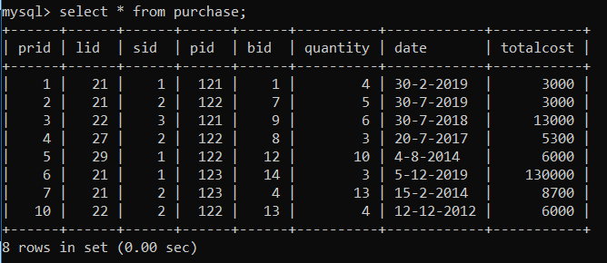

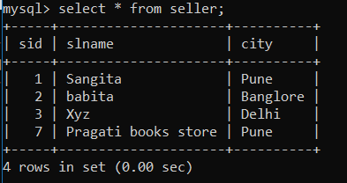

Q3:

Ans:

Number of Libraries in Pune:

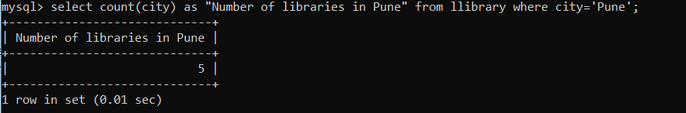

Institute that has CS branch:

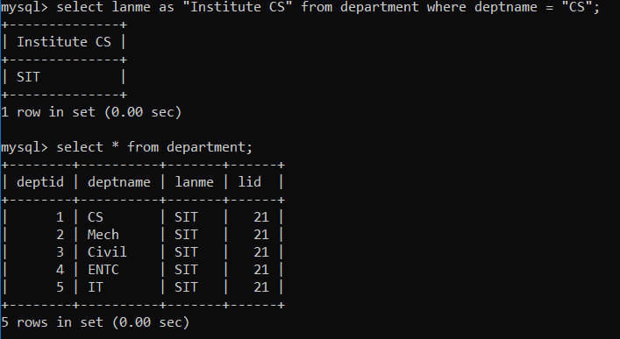

Books that are priced between 800 to 1500:

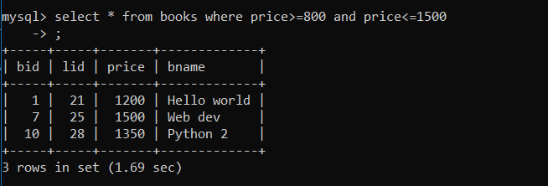

Employees whose salaries is less than 50000:

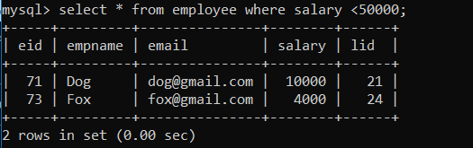

Sellers whose name ends with ‘ta’:

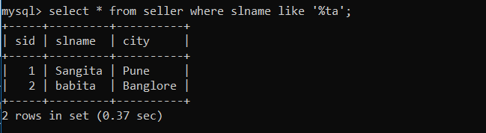

Institute where area info is missing:

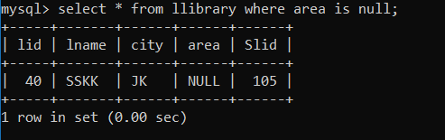

Staff member whose name doesn’t start with ‘A’:

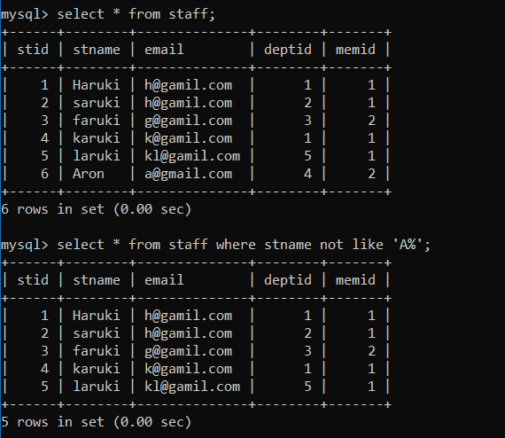

SIU Library located in bangalore:

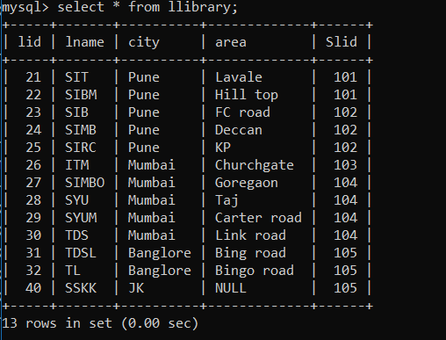

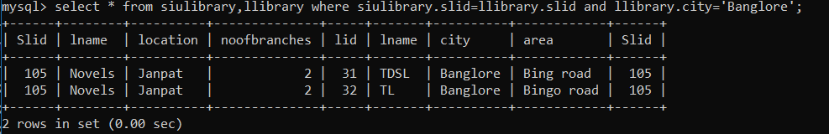

Students from civil department:

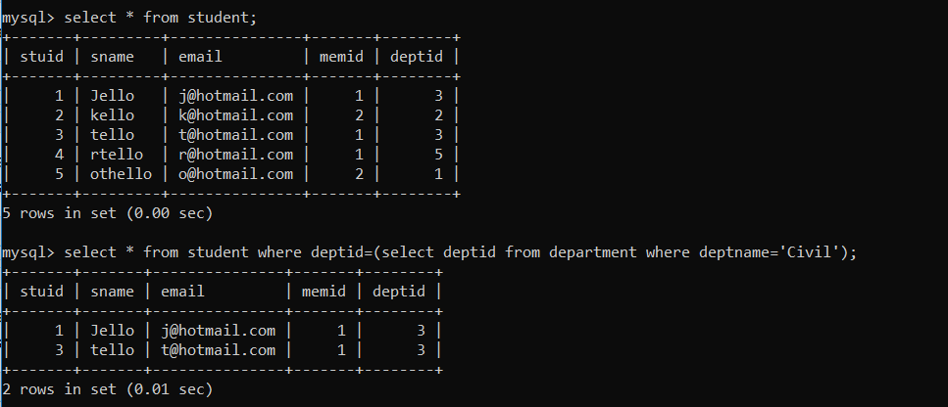

Books written by shruti and published by Mcgraw hill:

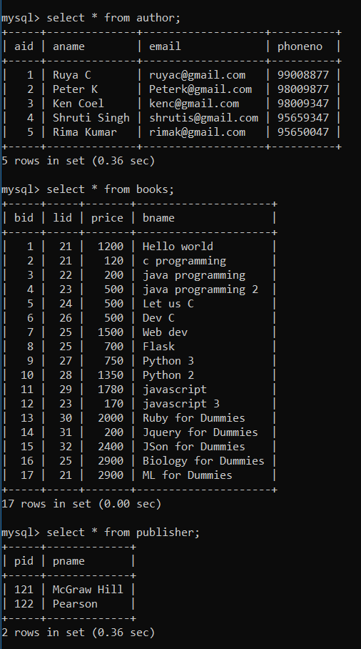

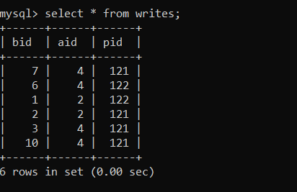

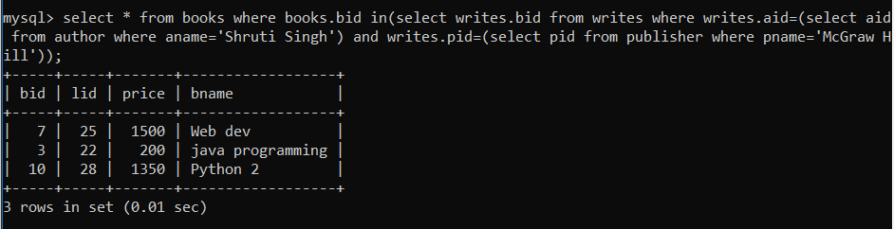

Members that have issued books belonging to ENTC of SITM:

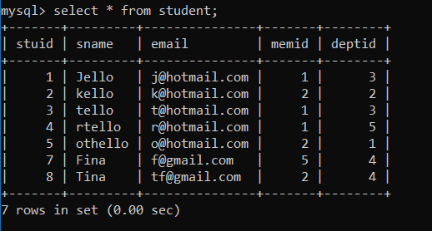

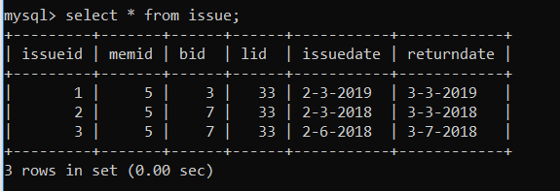

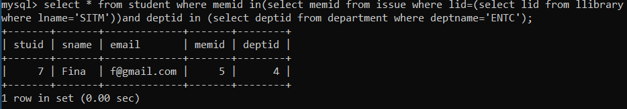

List books in SIT library:

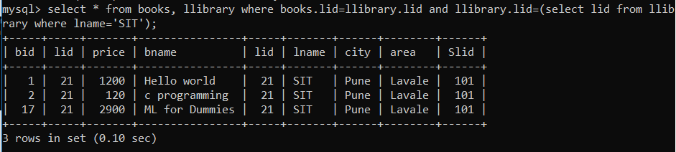

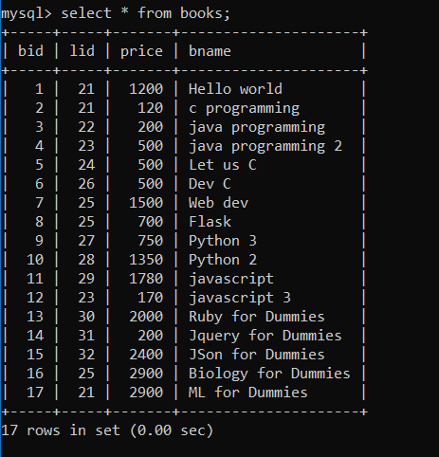

Books written by Ken Coel:

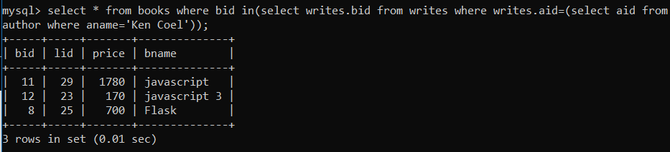

Staff whose salaries are less than atleast one employee:

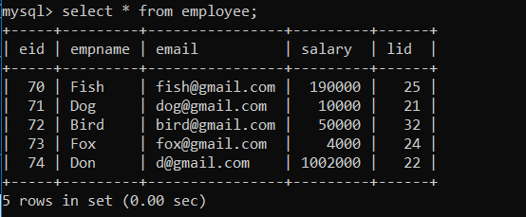

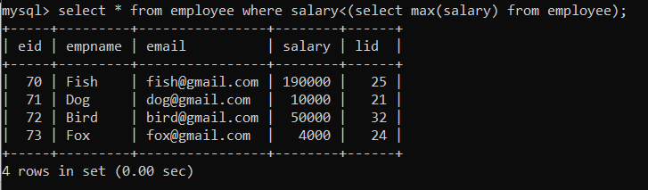

Books whose price is greater than atleast one book:

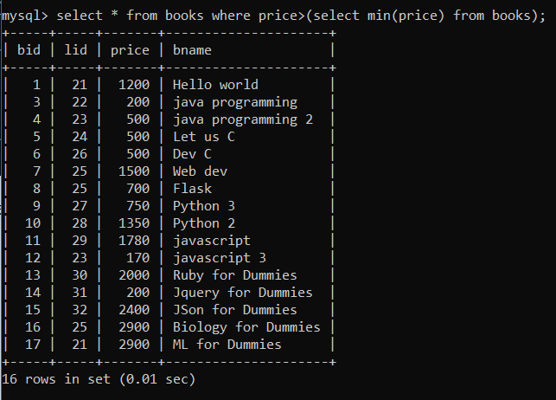

Employees whose salary is greater than all employees of cs department:

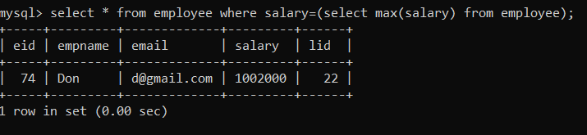

Such purchases whose total cost is greater than all purchases done by SIT library:

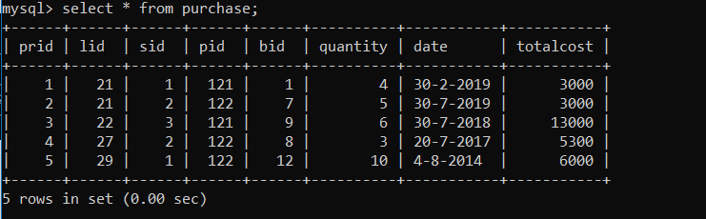

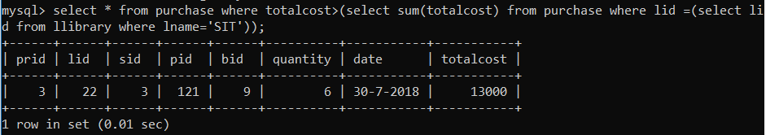

SIU library located in nashik and has library name SIOM library:

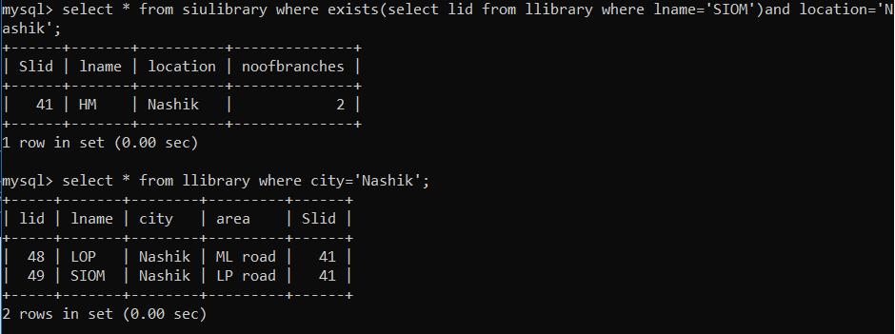

Staff member whose name starts with ‘S’ and don’t work for CS department:

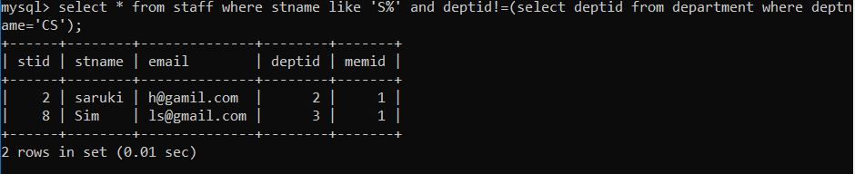

Books issued by Shivani:

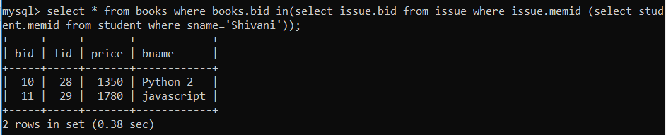

Seller from which SIT library purchased books of ‘Technical publications’:

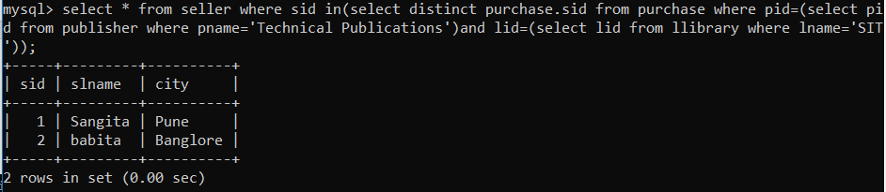

Books issued by staff of SSLA law department:

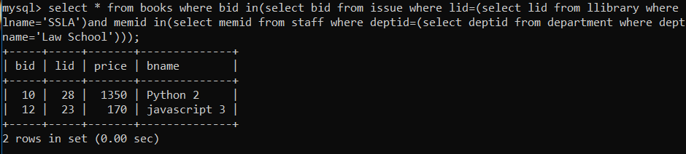

Seller resides in same city as SCHC library:

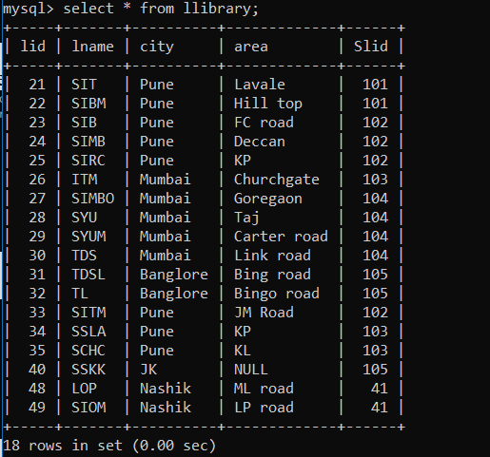

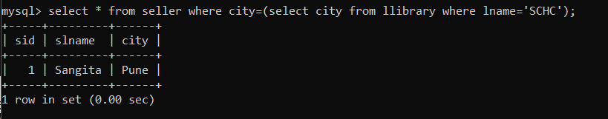

Publisher whose books are provided by seller ‘Pragati books store’ to SSBS library.



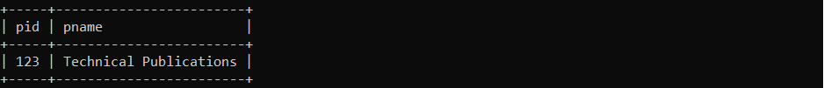

Books published by ‘Shivam kapoor’ with publishing house wiley publication:

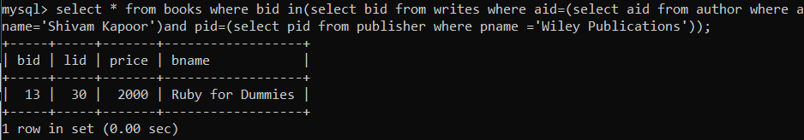

Purchase detail of SIBM for December:

 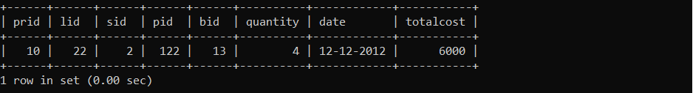

Institute member who have issued book no 453:

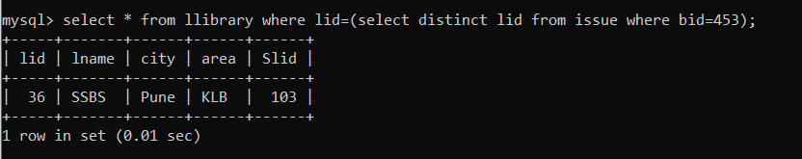

Increase prices of all books by 10%:

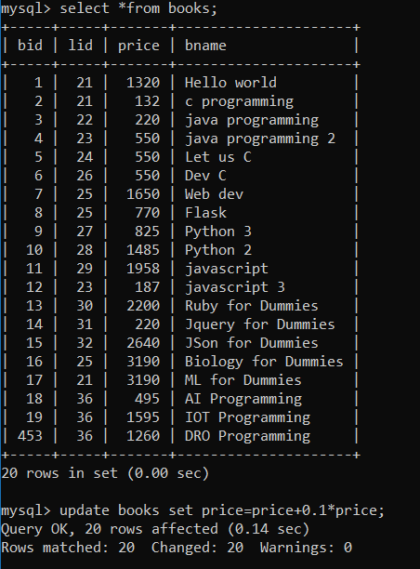

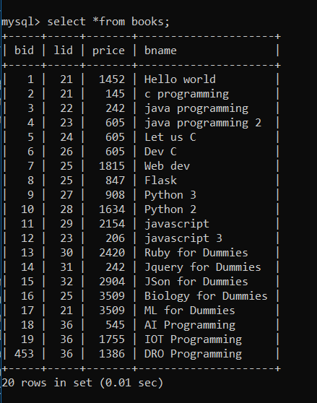

Change institute name to SSBS of biology department:

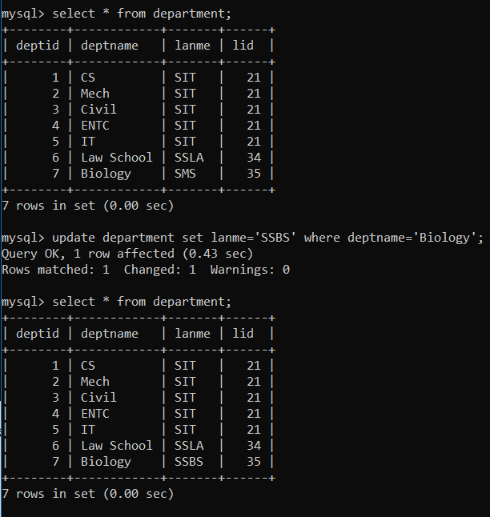

25% Diwali bonus to SIT staff:

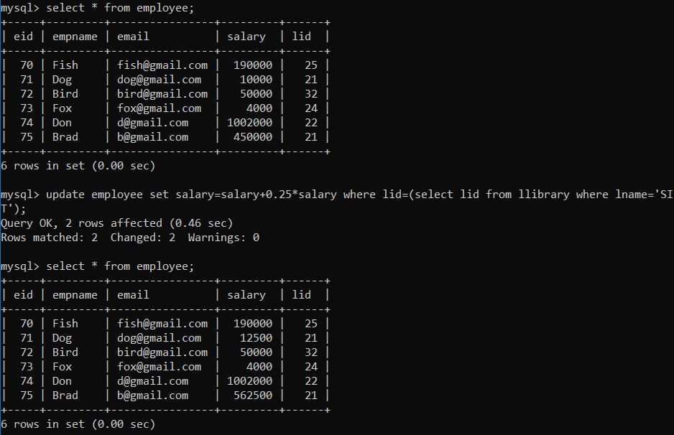

Delete purchase detail of 2016:

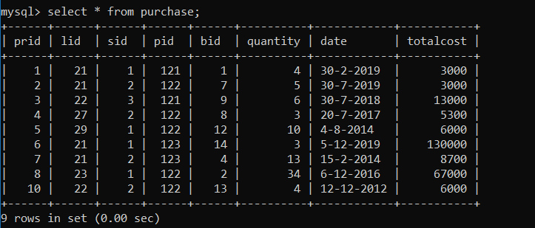

 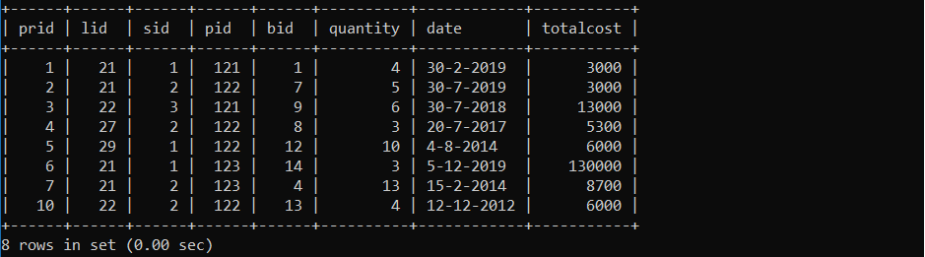

Delete issues where books are returned in 2010:

